Cbse –Spot.blogspot.com



# CLASS- IX

# MATHEMATICS (SA – II)

**TIME – 3 HOURS MAX. MARKS – 90**

**General instructions:-**

* All question are compulsory.
* The question paper consists of 34 questions divided into four sections A, B, C and D. Section – A comprises of 8 question of 1mark each. Section – B comprises of 6 questions of 2 marks each. Section –

C comprises of 10 questions of 3 marks each and Section – D comprises of 10 questions of 4 marks each.

* Question numbers 1 to 8 in Section – A are multiple choice questions where you are to select one correct option out of the given four.
* There is no overall choice. However, internal choice has been provided in 1 question of two marks, 3 questions of three marks each and 2 questions of four marks each. You have to attempt only one lf the alternatives in all such questions.
* Use of calculator is not permitted.
* An additional 15 minutes time has been allotted to read this question paper only.

# SECTION – A

1. Any point on the line x + y = 0 is of form
   1. b. c. d. (,−)
2. The coefficient of y in the equation 3(2x – y) + x + 2y = 5 is
   1. 7 b. – 5 c. – 1 d. 1
3. If in a sphere, volume and surface area are numerically equal, then radius will be:
   1. 1 b. 3 c. 2 d. 4
4. The length of longest pole that can be put in a room of dimensions (10m x 10m x 5m) is
   1. 15m b. 16m c. 10m d. 12m
5. If in a quadrilateral, diagonals are equal, then it cannot be a :
   1. Square c. Rhombus
   2. Parallelogram d. Rectangle
6. The median of a triangle divide it into two
   1. Triangles of equal area c. Right triangles
   2. Equilateral triangles d. Isosceles triangles.
7. A fair die is thrown. The probability that a prime number will occur is
   1. b. c.  d. 
8. If the mean of x, x +2, x+4, x+ 6, x+ 8 is 24, then x =
   1. 22 b. 21 c. 20 d. 24

# SECTION – B

1. The curved surface area of a right circular cylinder of height 14 cm is 88 cm2. Find the diameter of the base of the cylinder. Assume π = 22/7.
2. In a cricket math, a batswoman hits a boundary 6 times out of 30 balls she plays. Find the probability that she did not hit a boundary.
3. The blood groups of 30 students of Class VIII are recoded as follows:

A, B, O, O, AB, O, A, O, B, A, O, B, A, O, O, A, AB, O, A, A, O, O, AB, B, A, O, B, A, B, O.

Represent this data in the form of a frequency distribution table.

1. The following observations have been arranged in ascending order. If the median of the data is 63, find the value of x. 29, 32, 48, 50, x, x + 2, 72, 78, 84, 95
2. A chord of a circle is equal to the radius of the circle. Find the angle subtended by the chord at a point on the minor arc and also at a point on the major arc.

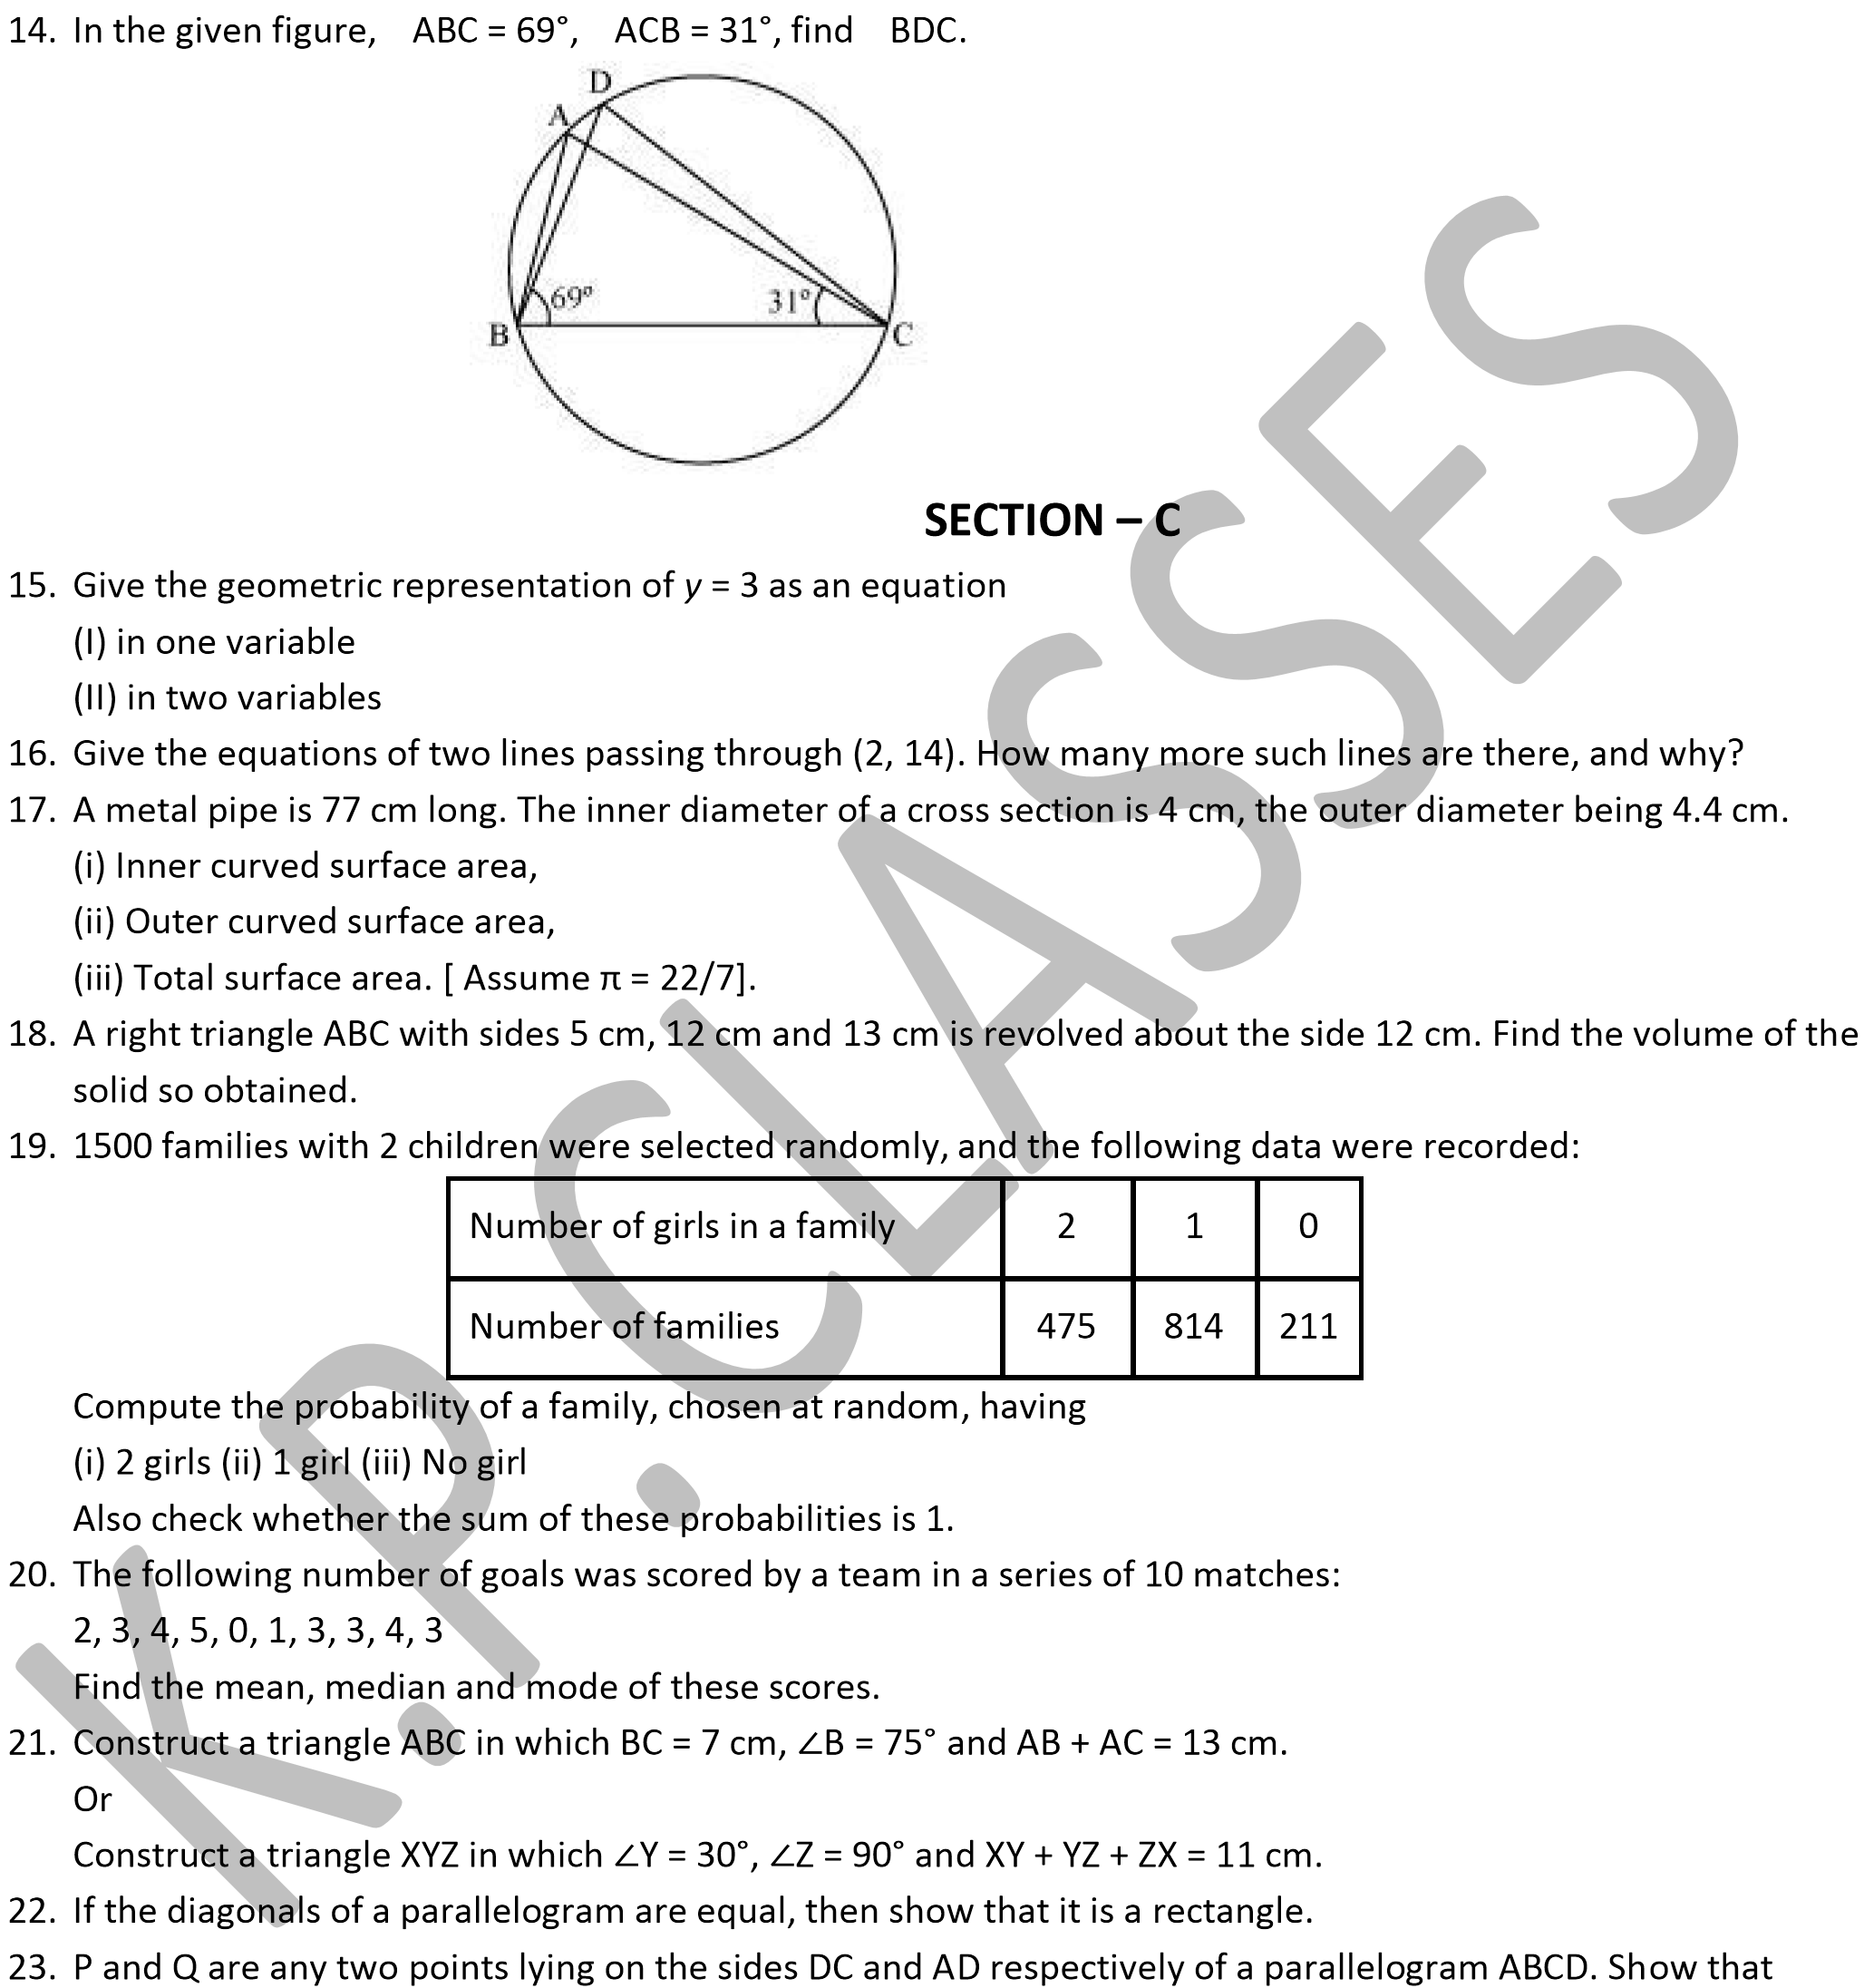

ar (APB) = ar (BQC).

24. In a triangle ABC, E is the mid-point of median AD. Show that ar (BED) = ar (ABC)

# SECTION – D

1. If two circles intersect at two points, then prove that their centres lie on the perpendicular bisector of the common chord.

1. Prove that parallelograms on the same base and between same parallels have the same area.
2. ABCD is a rhombus and P, Q, R and S are the mid-points of the sides AB, BC, CD and DA respectively. Show that the quadrilateral PQRS is a rectangle.
3. The taxi fare in a city is as follows: For the first kilometre, the fares is Rs 8 and for the subsequent distance it is Rs 5 per km. Taking the distance covered as *x* km and total fare as Rs *y*, write a linear equation for this information, and draw its graph.

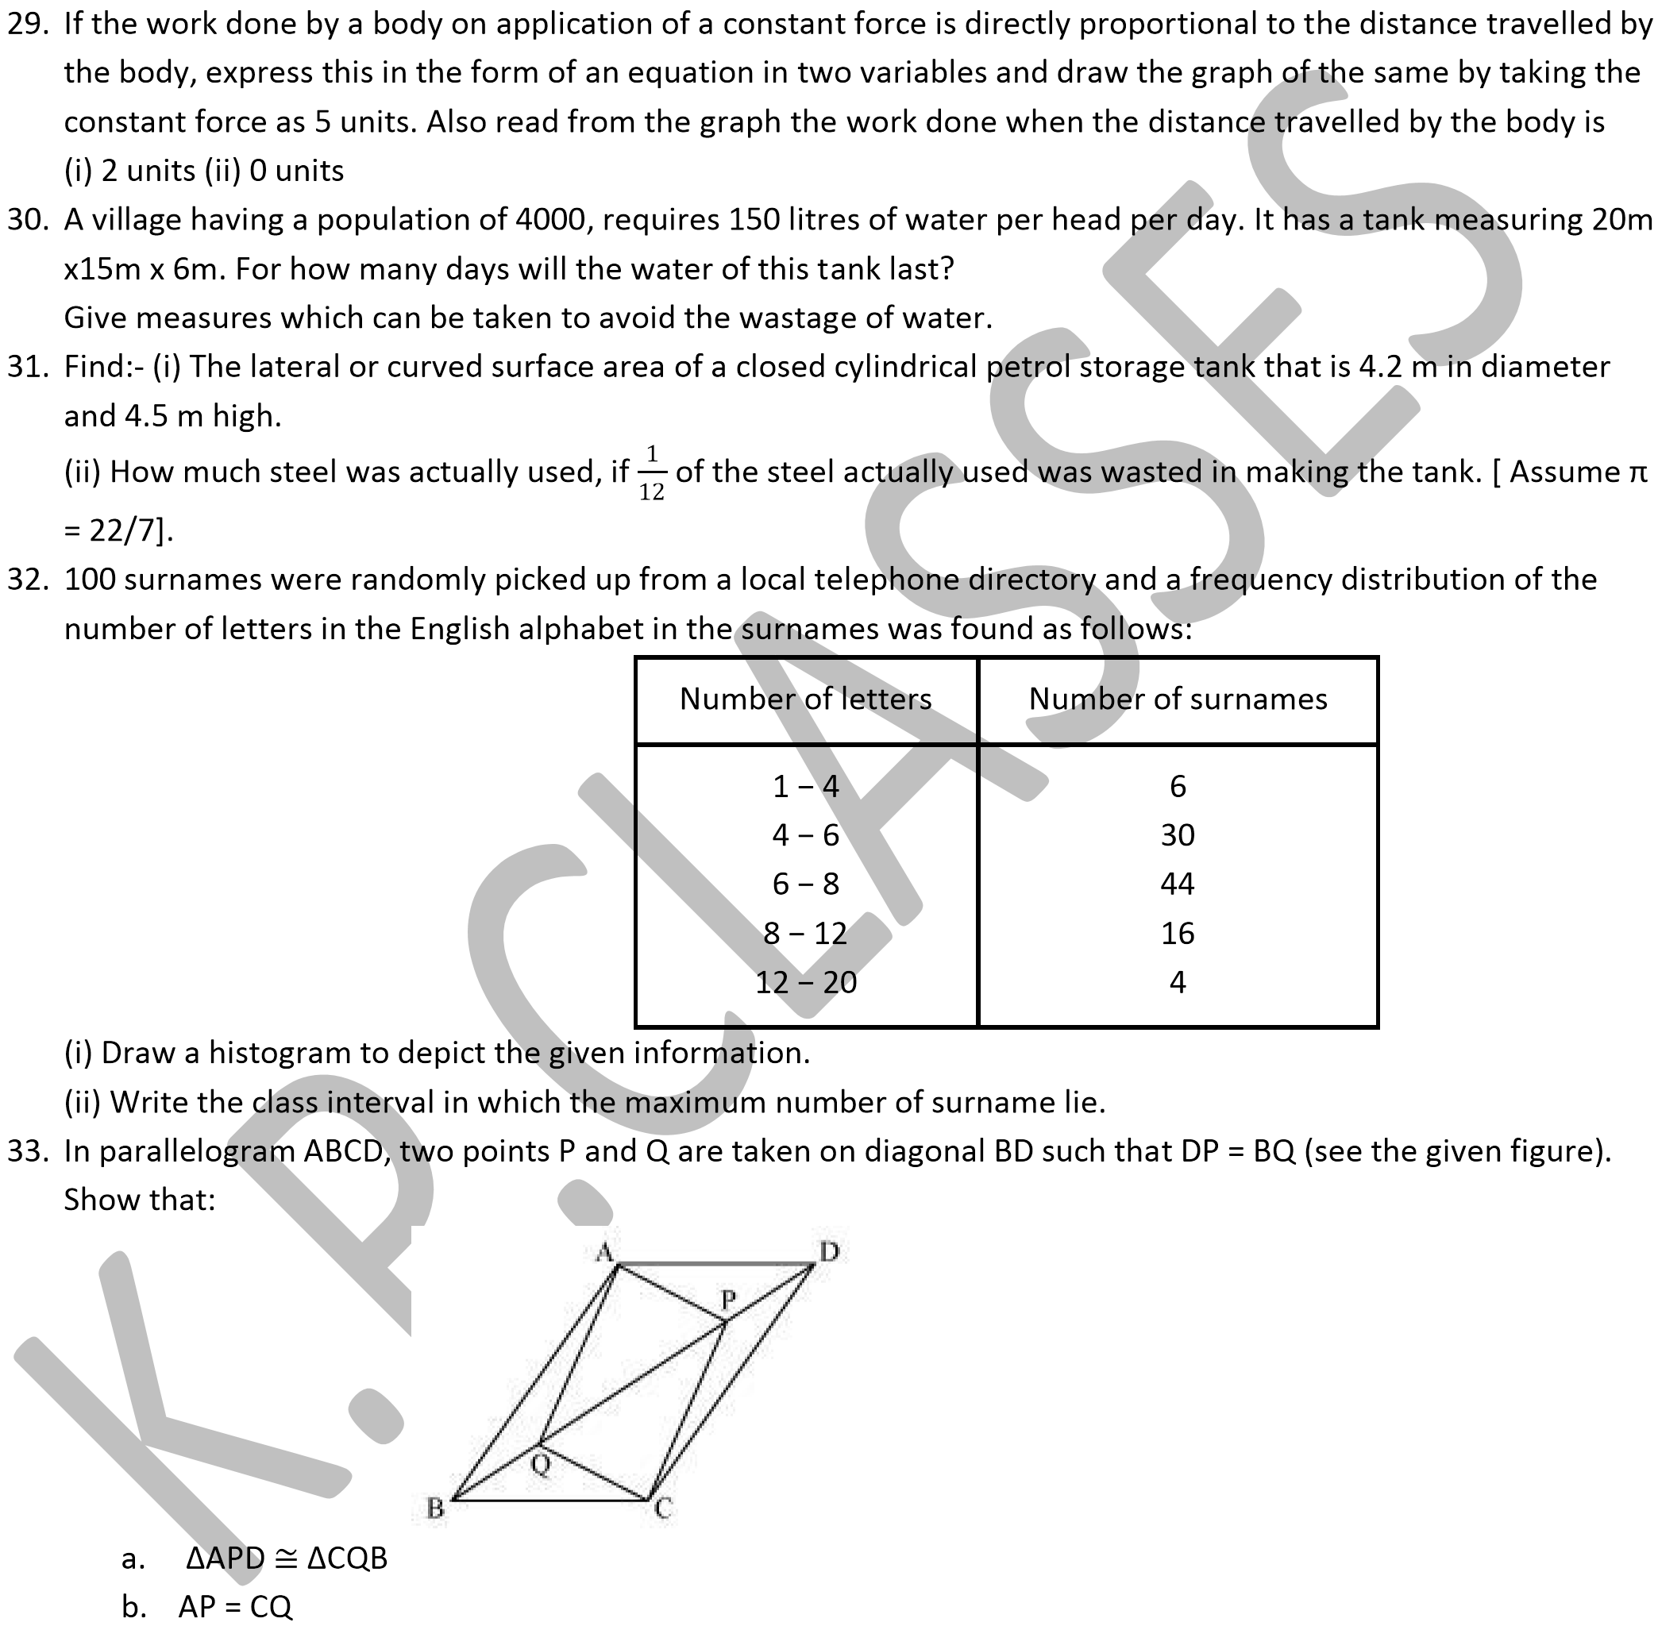

* 1. ΔAQB  ΔCPD
  2. AQ = CP
  3. APCQ is a parallelogram

34. Prove that the angle subtended by an arc at the centre is double the angle subtended by it at any point on the remaining part of the circle.